**How to create an Advanced eDiscovery case?**

* **Step 1:** Navigate to the security and compliance center.
* **Step 2:**Click “Advanced eDiscovery” under eDiscovery from the left-hand side menu bar.
* **Step 3:** Click “Cases” on the menu bar on the top and click “+ Create a case”.

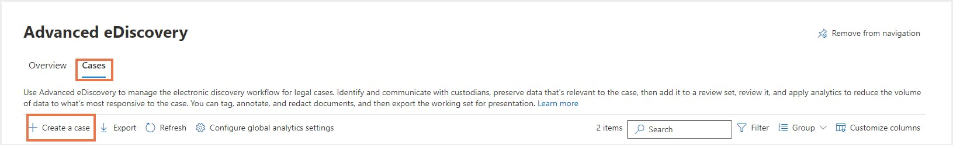

* **Step 5:**Enter a case name, case number, and a description (optional). Administrators can further add members to configure the analytical settings related to the case and the format. Click "Save".

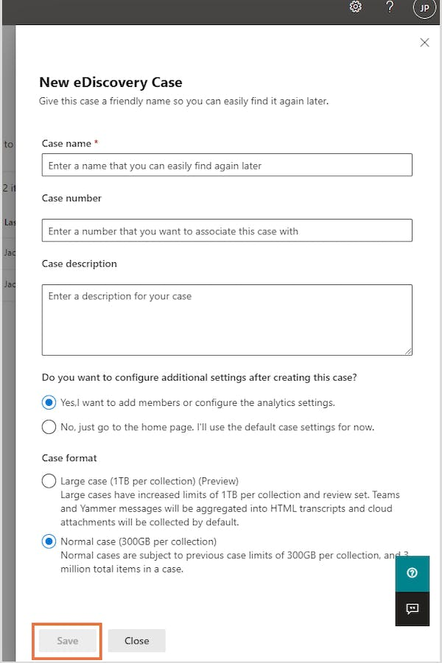

#### How to create collections in an Advanced eDiscovery case?

A collection in Advanced eDiscovery is like a content search run in a Core eDiscovery case.

To create a collection, follow the below steps:

* **Step 1:** Navigate to the security and compliance center and click “Advanced eDiscovery” under eDiscovery on the left-hand side menu bar.
* **Step 2:** Click “+ Create a case” or choose an existing case. Click “Collections” on the top menu bar and click “+ New collection”.

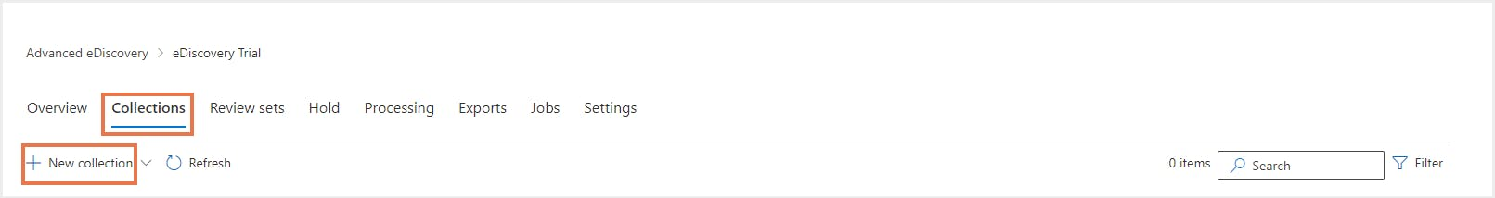

* **Step 3:** Enter the name and description (optional) of the collection, add custodians, non-custodial data sources, additional locations, conditions for the collection, save the collection as draft or add it directly to a review set. Admins can review the collections once the collection process is done.

